**Press release: First Days founder and CEO made MBE | June 2023**

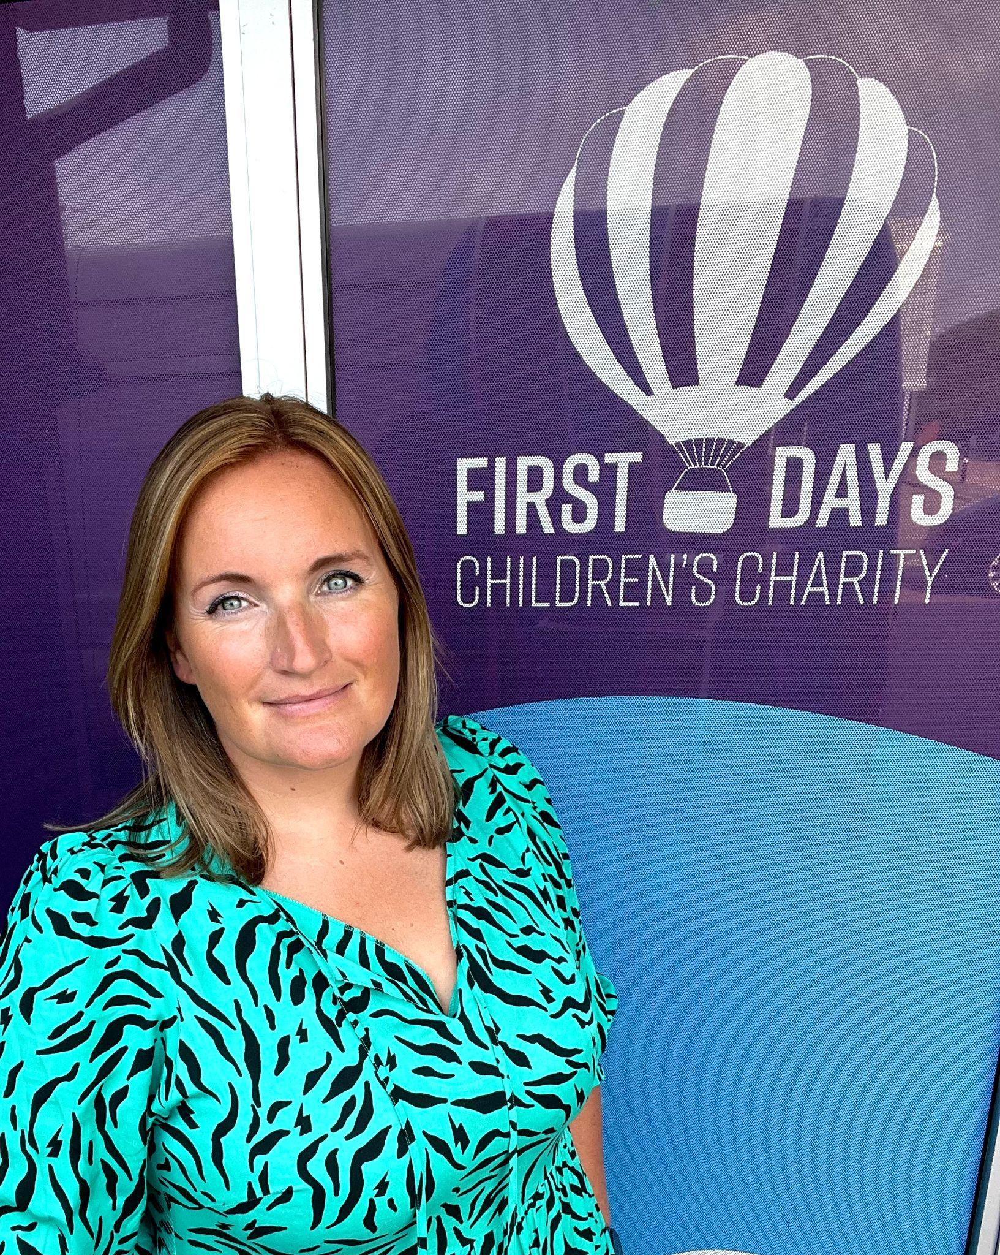

**First Days CEO honoured in King’s Birthday list for services to vulnerable children**

The founder and CEO of First Days Children’s Charity, Emma Cantrell, has been made an MBE in the King’s Birthday Honours list.

Emma received the honour for her services to vulnerable children.

She founded First Days in 2013 to help local families who were struggling to provide everyday essentials, making it her personal mission to ensure no child in the area goes without.

Over the last decade, the charity has grown from a baby bank to provide everything from the moment a baby is born to the moment a child leaves school, alongside specialist support for parents so that they may never need to use charitable services again. Under Emma’s leadership, First Days has helped over 25,000 children, and distributed over 500 tonnes of donated goods.

In an affluent area like Berkshire, it can surprise people to hear that First Days supports over 8,000 children every year, despite most having parents in work.

However due to the cost of living crisis, in Berkshire over 45,000 children in Berkshire live below the poverty line. After the cost of housing and utilities, their parents have less than £19 a day to live on for food, clothes, fuel, transport and everyday basics, despite their best efforts.

The impact of inequality on children in such an affluent area cannot be overstated. When a child comes to school hungry, having not slept in their own bed, wearing a secondhand uniform or without the right kit, and sits next to a child who has everything, they can feel unequal and less than.

It is Emma’s dream to level up that playing field, so that those children have every chance the same as their peers, so they do well at school, so they are healthy and so they thrive into adulthood.

No stranger to the need to shout about this message, Emma has become a familiar face in media coverage discussing the need for political change to address these issues. She is often seen in the national press talking about the importance of small charities, the reality of life for low-income families and the need for affordable childcare and housing. She has put affordable uniforms on the news agenda, influenced local schools to change their policy on specific pieces of uniform and worked with the local authority to make the school day more affordable for everyone.

During the Covid 19 Pandemic, Emma led the Borough’s emergency response to food provision, setting up and running a food hub, which, with the help of 120 volunteers, distributed over 8,000 food parcels to vulnerable residents.

In the last ten years Emma has raised over £1.5m to support the local children and families and supported many other women by mentoring them to start their own charities in their area.

**Quotes**

“This is an incredible honour, which I am humbled to receive. This work has been a labour of love for a decade of my life and I never fail to be utterly blown away by the incredible families we support. It is an honour to be able to play a part in restoring dignity, choice and power to our local community through the work of First Days Children’s Charity. We don’t do this work for recognition, but if more people like me can be recognised in this way then that would be brilliant for the communities we serve. I am privileged to be surrounded by a fantastic team of staff and volunteers who work tirelessly to support families. Despite the very difficult circumstances we find ourselves in during a cost of living crisis and a funding crisis for the small charity sector, we continue to work hard to help as many families as we can. I hope that this honour will show more people the fantastic work that First Days’ does so we can carry on supporting families for as long as they need us.”

Emma Cantrell, MBE

“We are incredibly proud of the hard work, passion and dedication with which Emma leads First Days. Throughout the pandemic, the Ukrainian refugee crisis and now the cost of living crisis Emma has led the charity with courage and is never afraid to speak truth to power, as a voice for the families she so passionately cares about. We hope that this honour takes her and the charity from strength to strength.”

Rob Cant, Chair of Trustees

**About First Days Children’s Charity**

**What do we do?**

We support families who are experiencing financial hardship. We offer emotional, practical and specialist support via our Family Support Team. We also help families access the support they need from other organisations, and we distribute essential items via our Baby Bank, School Uniform Centre and Safe Place to Sleep project. The immediate support we give to families via the distribution of essential items is the first building block in longer term support to help families in other areas of their lives. By helping parents in their moment of crisis, like 'my son has lost his school shoes and I can't afford to replace them!', we alleviate the immediate crisis and then can work with families to see if there is more support out there for them, so they never need to make that phone call again!

**Why do we do it?**

We believe that every child deserves the same start in life and that parents might need some help accessing the support, tools and skills they need to give their children the best life possible.

Evidence from the Child Poverty Action Group shows that when children, in both their early years and at school, feel that they are equal to their peers they achieve more, do better in exams and can get better jobs.

But, mostly, we believe that there are times in most parent's lives when they need some extra support in one way or another, and we want to be there to provide that support so children in our community are safe at home, confident at school and have fun.

**How do we do it?**

Our Family Support team is dedicated to supporting families. Families can contact us directly for support with accessing our projects and services, emotional and practical support and signposting and advocacy to other support services.

For more information or pictures, please visit [www.firstdays.net](http://www.firstdays.net) or contact our Marketing Officer at monica@firstdays.net